

A Project

Report On

**E-commerse Website**

By

**1.Ankita Anant Sutar. 2. Priyanka Koppishetty**

**3.Surbhi Malviya. 4.Gauri Chinachkar.**

**5.Dnyaneshwari Satpute.**

**B.E Computer Engineering**

**Batch: - 2020-5735**

**Center: -Thane**

Under the Guidance of,

**Shalini Kumari.**

**Technical Trainer**

**EduBridge**

(School of Coding)

**Introduction:**

This Project  **E-commerse Website** has been developed by using HTML language and design by using CSS. This is a website help us to online shopping.

The purpose of this website is to continuously raise the bar of the customer experience by using the internet and technology .

This website helps customers to find, discover and buy anything and empower businesses..

In this website, users can see what Services we offers. In this website,

Customer can create account by using registration process also login into an account. and shop by adding product to the cart.

.

Software Requirements:

Front end: HTML and CSS

IDE: VS Code

BackEnd: Javascript

Operating System: Window 10

Output:

**1. HomePage:**

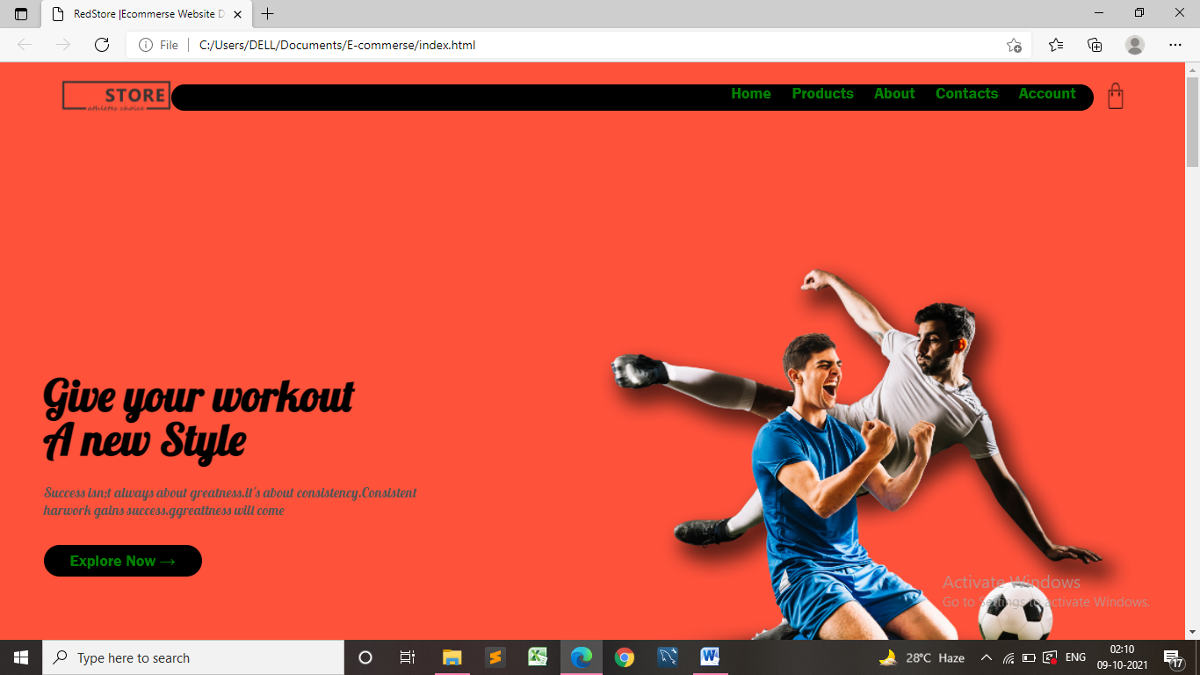

Fig: 1

**2.Featured-Products:**

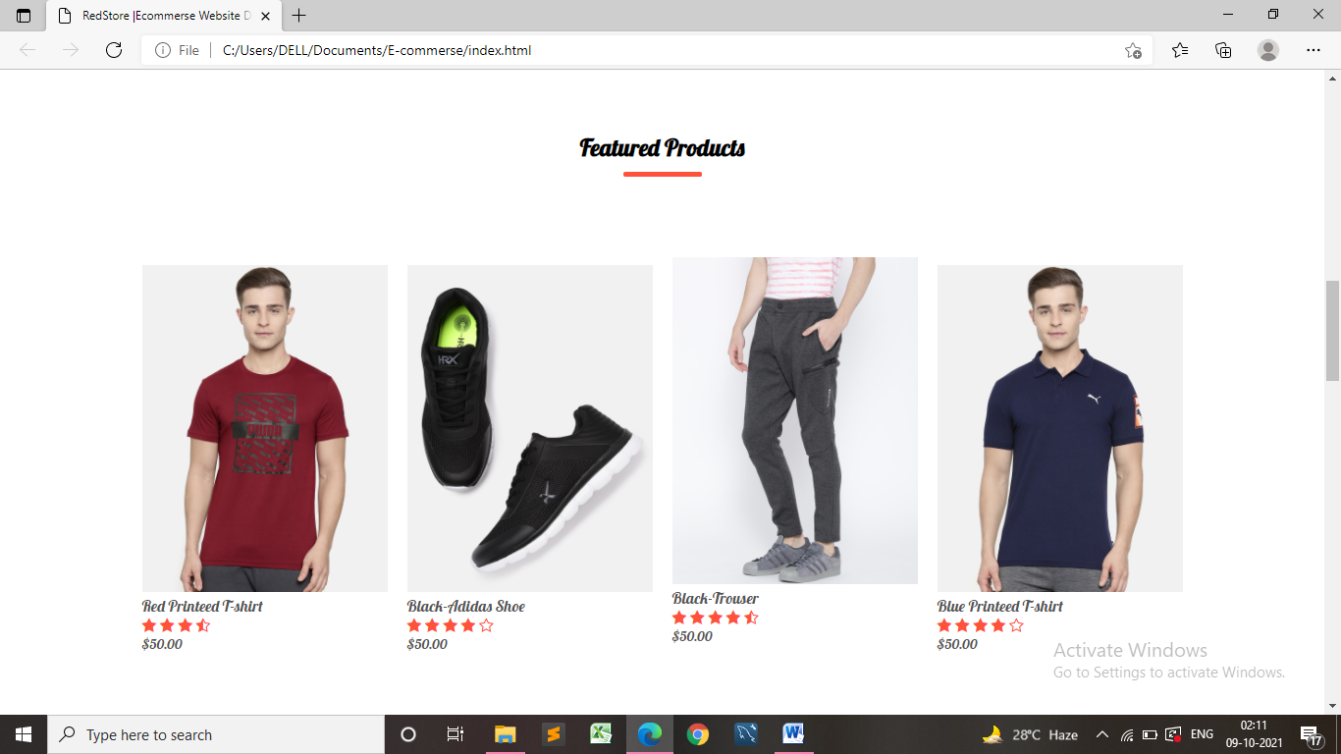

Fig : 2

**3.Latest-products**:

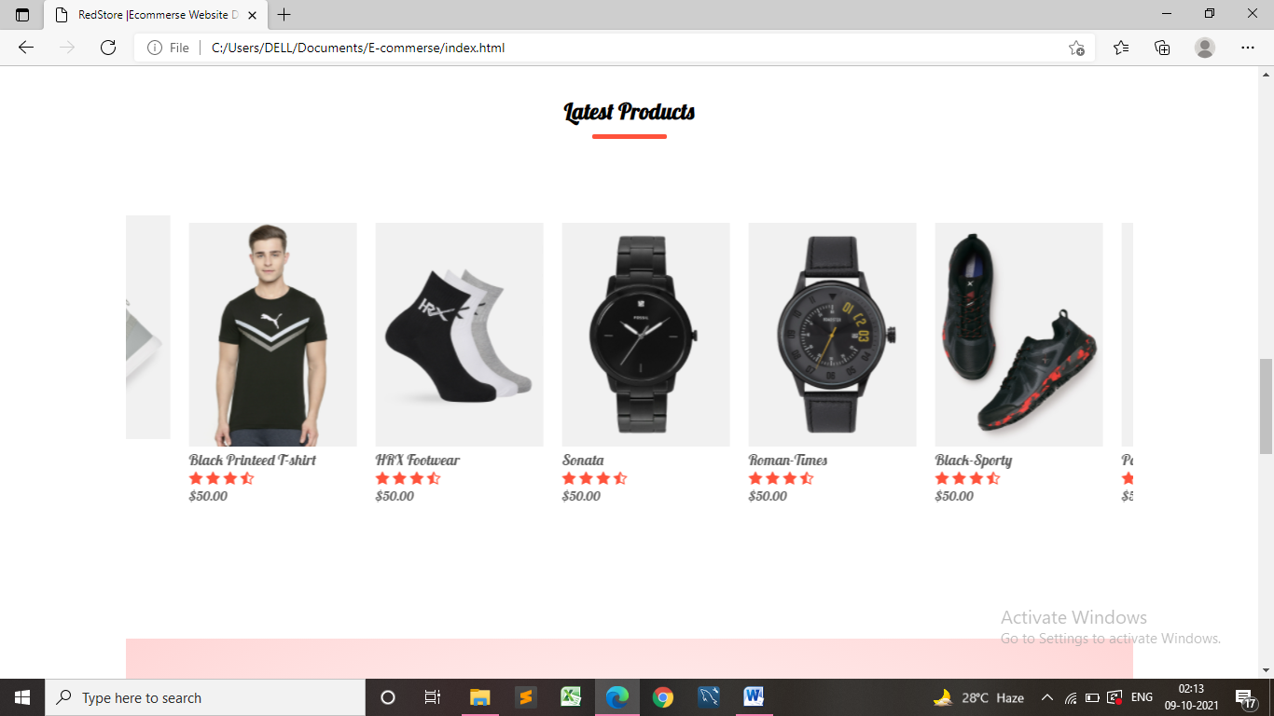

Fig: 3

**4. Exclusive-Offer :**

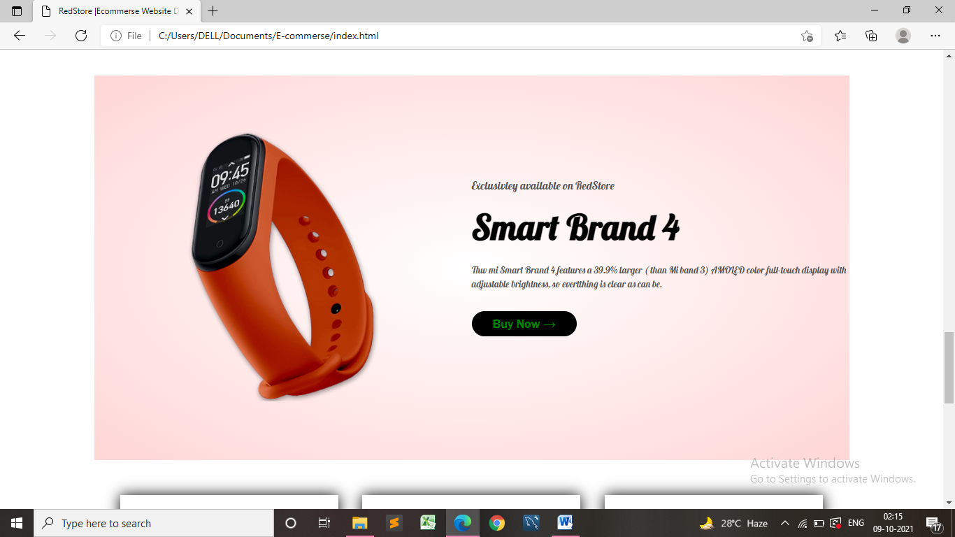

Fig: 4

**5.Testimonials & Parteners :**

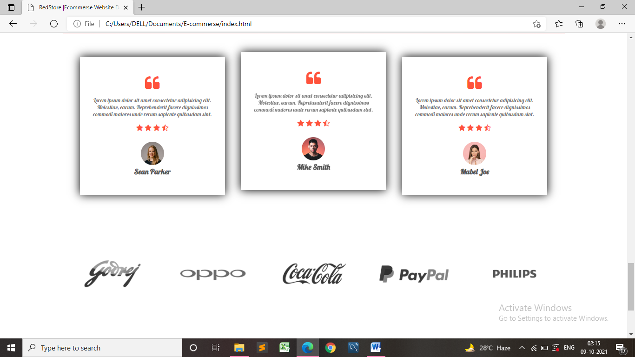

Fig: 5

**6.All-Products:**

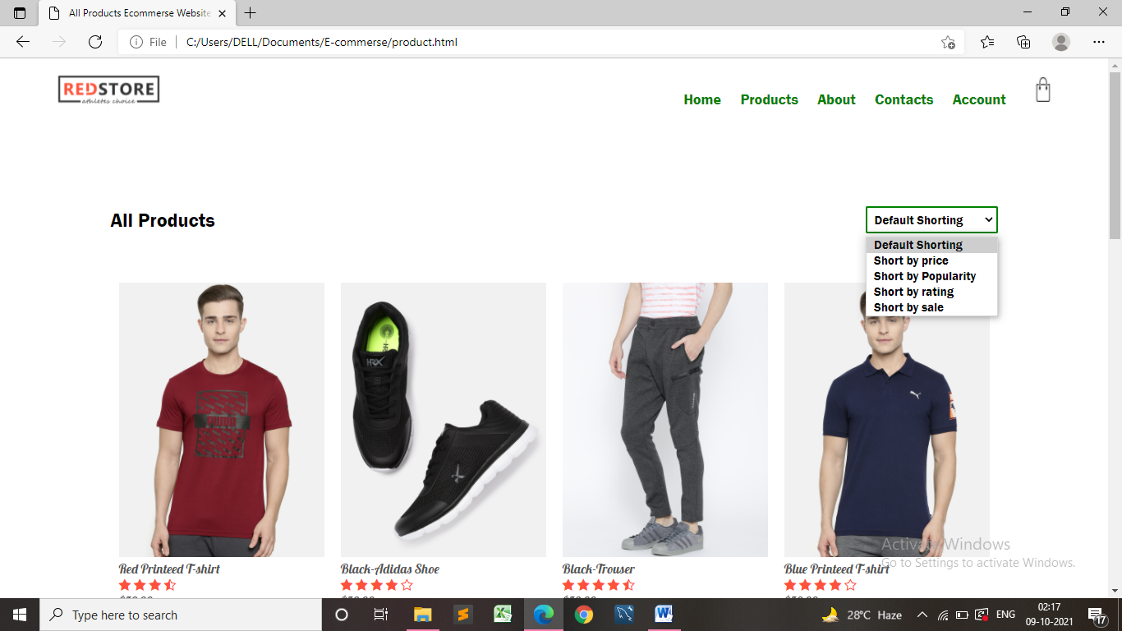

Fig: 6

**7. Login & Registration Page:**

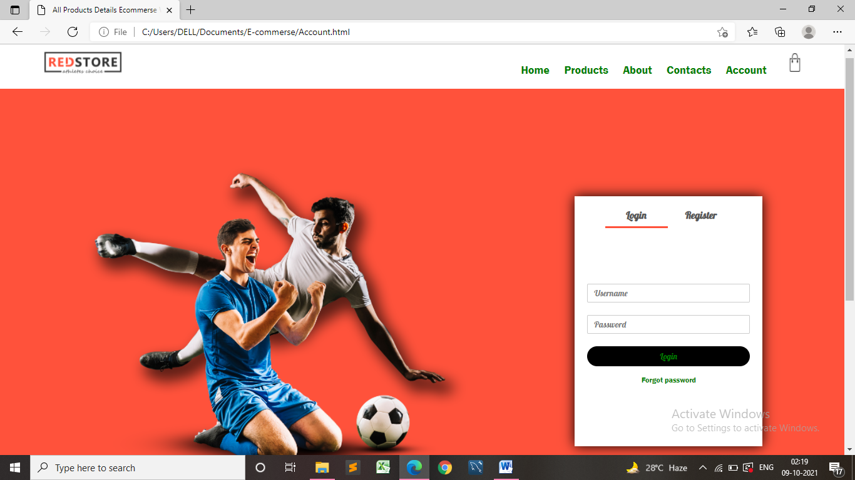

Fig: 7

**9. Products-Detail page:**

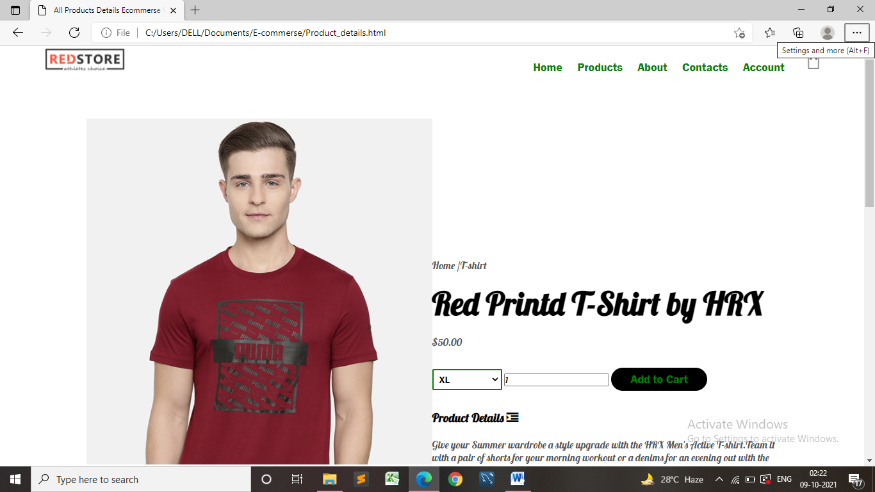

Fig: 9

**10. Footer:**

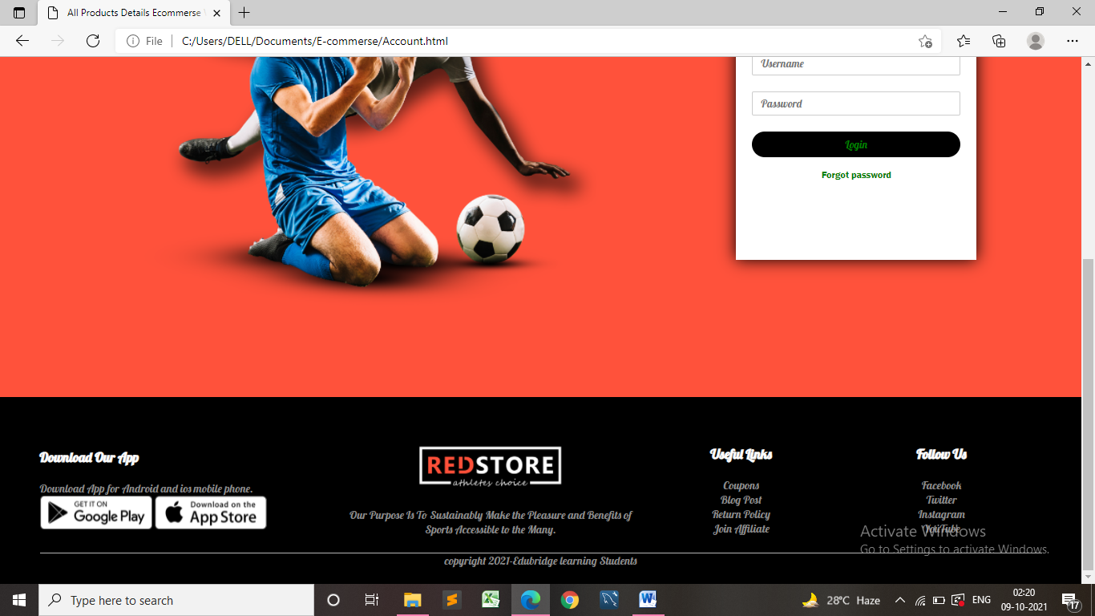

Fig: 10

***Interior Designer Website***

***Has been completed***